IU Logo (New)

**FACULTY OF ENGINEERING, SCIENCES AND TECHNOLOGY**

**Memory Management**

1. Consider the free memory layout shown below (the blocks are ordered from top to bottom). Draw to what the free memory layouts would be after satisfying requests for (in order) memory blocks of size 75K, 410K, 281K, and 295K. Draw one memory layout for the best-fit algorithm, and one for first-fit.

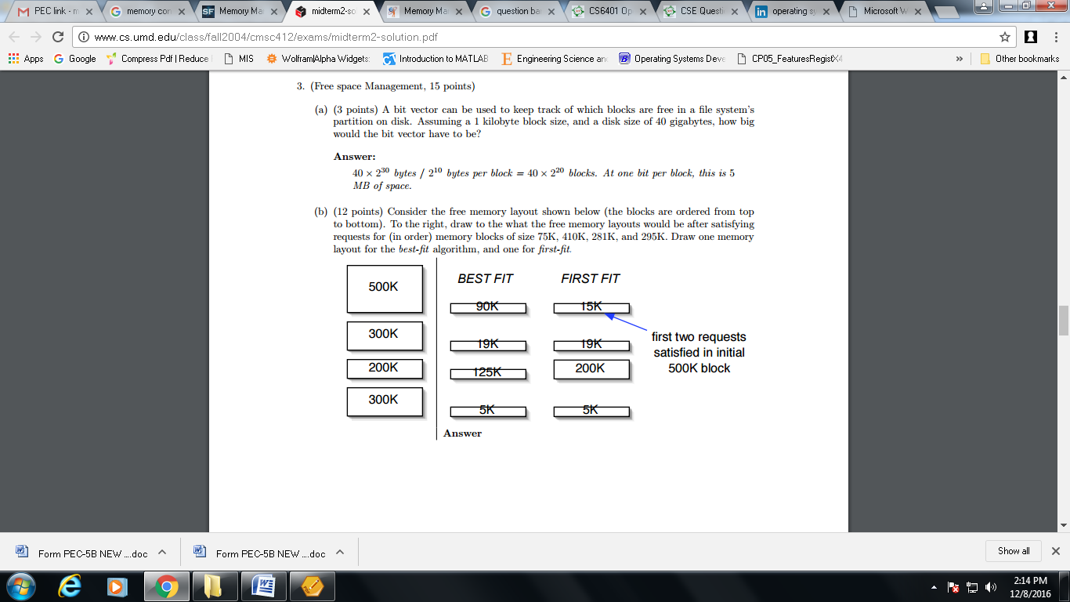

1. Assume that the main memory has the following 5 fixed partitions with the following sizes: 100KB, 500KB, 200KB, 300KB and 600KB (in order)

a) How would each of the First-fit, Best-fit and Worst-fit algorithms place processes of 212KB, 417KB, 112KB and 426KB (in order)?

b) Which algorithm makes the efficient use of the memory?

1. Consider the memory layout shown below

|  |  |  |  |  |
| --- | --- | --- | --- | --- |
| **50** | **150** | **300** | **350** | **600** |

a) How would each of the First-fit, Best-fit and Worst-fit algorithms place processes of 300KB, 25KB, 125KB and 50KB (in order)?

b) Which algorithm makes the efficient use of the memory?